Week 3

What constitutes a good password?

*The following fictional story is based on real events.*

Cindy was on the bus, almost home from her small shopping trip. She gathered her bags and noticed the clasp of her purse was undone. She double-checked and saw that her wallet and other belongings were still inside, so she refastened the purse clasp and exited the bus.

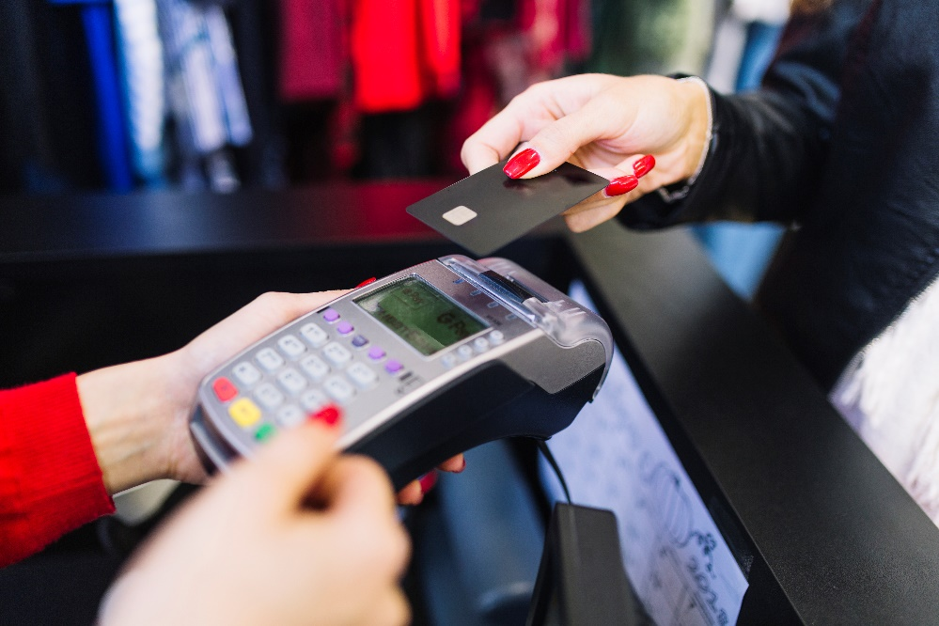

*(image credit: Freepik)*

Safe at home, Cindy put away her purchases and checked her purse again. She pulled out her wallet, and only then noticed that her debit card wasn't there. She thought she remembered putting it back into her wallet at the last store she visited, but just in case, she checked her other bags. She still didn't find it. Where could it be?

She then logged into her bank's online web site to check on her debit account. Her balance was almost zero! She quickly looked at the list of transactions, and in addition to the purchases she had made, it also showed several large debit purchases from nearby stores that she had never visited. Cindy began to panic. The banks and stores were closed for the day, but she found a toll-free telephone number on the web site, and quickly called it. After fumbling through several “press 1 for balances, press 2 for loans” style voice menus, she finally was able to speak with someone and report that her card had been stolen and used. During the report, she was dismayed to discover that the thief knew her PIN, and used it on each of the fraudulent transactions that together nearly emptied her account.

It took Cindy several frustrating days to get a replacement debit card and to have the thief's spending credited back to her account.